# Cute Http File Server JWT English

Offical website address:<http://iscute.cn/chfs>

Offical github website address：<https://github.com/ods-im/CuteHttpFileServer>

# Get Cookies for Admin

This project has no registration function, so we need to set up a local environment,create a user manually。Let's create an admin user here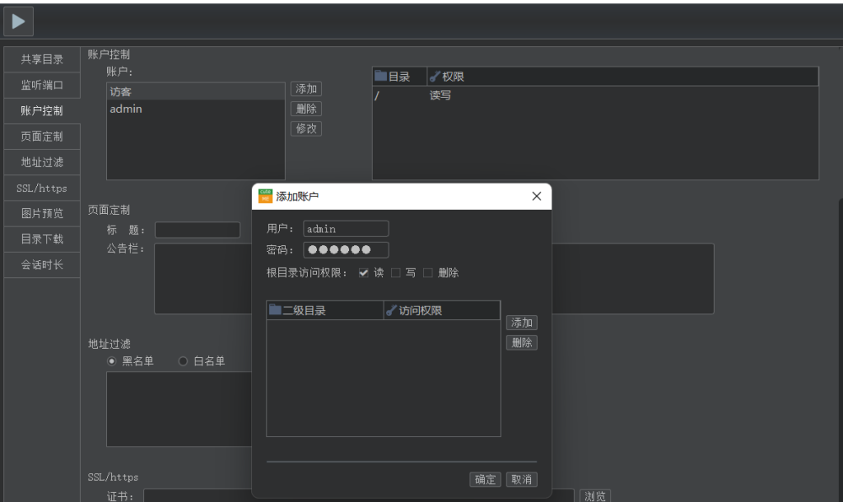

then locally login

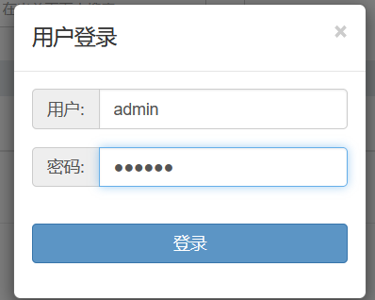

**and obtain their cookies after login successfully**

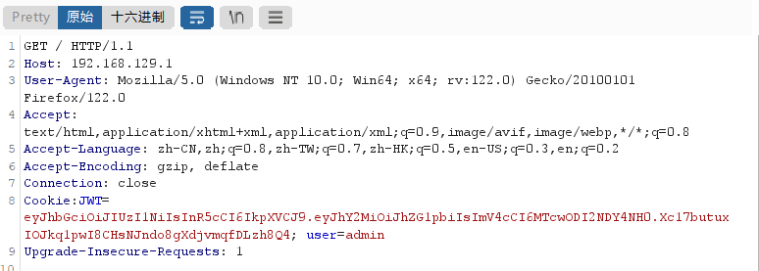

# JWT Decryption and Forgery

JWT decryption, the payload only contains the admin user we just registered, without verifying the current user's password. At the same time, the symmetric key has also been decrypted. From then on, any identity login can be achieved using JWT

Note: payload has a time limit, if it expires, please log in again to capture the new cookie

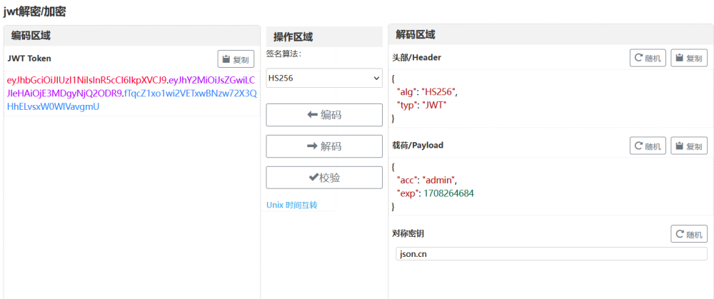

# Experimental effect

Now we are trying not to use a password, but to use our forged JWT to achieve login

## before login

### first

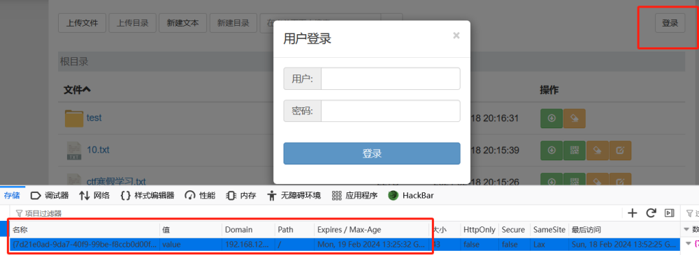

### second

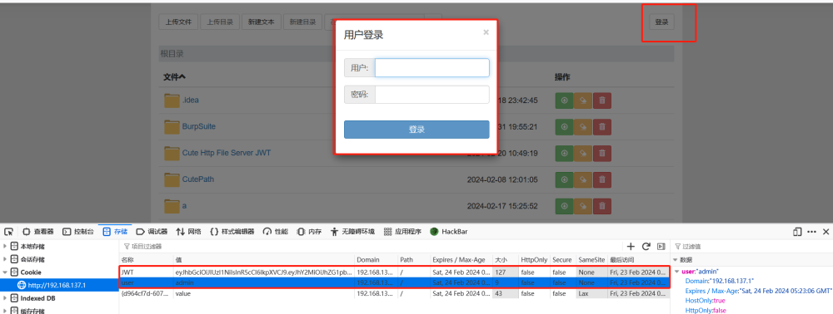

## successful jwt forgery

F5刷新浏览器，发现管理员用户在没有密码的情况下成功登录。因此，我们可以按照上述方法实现任何身份的登录

